Deliverable D2.1: Description of the measurement site

From:

Date: 30 September 2016

To: EUROPEAN SPACE AGENCY (ESA)

The European Space Research Institute (ESRIN),
Via Galileo Galilei,
Casella Postale 64,
00044 Frascati (Roma),
Italy

Att.: Sara Pancotti

Subject: ESA-IPL-POE-LG-cl-LE-2015-1129
Title: Fiducial Reference Measurements for Ground-Based IR Greenhouse Gas Observation (FRM4GHG)

Category: ESA Express Procurement (EXPRO)

Our ref.: Proposal No. 1129/2015 –
Proposal from February 16, 2016 plus comments from May 27, 2016

_______________________________________________________________

Dear Sir or Madam,

With reference to the above Request for Proposal (RFP), please find our Deliverable D2.1: Description of the measurement site to be delivered at T0 + 2 month. If you have further questions, please let me know.

Regards

Description of the measurement site

The campaign will be performed in Sodankylä at the TCCON facility of the FMI. The TCCON instrument will serve as reference for all other spectroscopic observations.

All other spectrometers of FRM4GHG will be installed in a separate 30 feet container. The container is located in the vicinity of the TCCON building: about 30 m South. The TCCON facility is equipped with Bruker IFS 125HR spectrometer and a large solar tracker A547N, manufactured by Bruker Optics. The TCCON instrument has been operational since early 2009 (Kivi and Heikkinen, 2016).

AirCore balloon observations will be performed from the FMI balloon facility. The AirCore and other sondes can be launched within 70-80 meters West from the FRM4GHG container. Alternatively a mobile launch system can be considered. The mobile sounding system is available at the FMI facility. This includes a trailer with balloon filling equipment and a radiosonde receiver system. The AirCore analysis after each flight will be performed at FMI using a Cavity Ring-Down Spectrometer (Picarro Inc., CA, model G2401). The AirCore laboratory is currently located on the ground floor of the TCCON building. Continues measurements of CH4, CO, CO2 are performed at a tower located within less than a kilometer from the TCCON building.

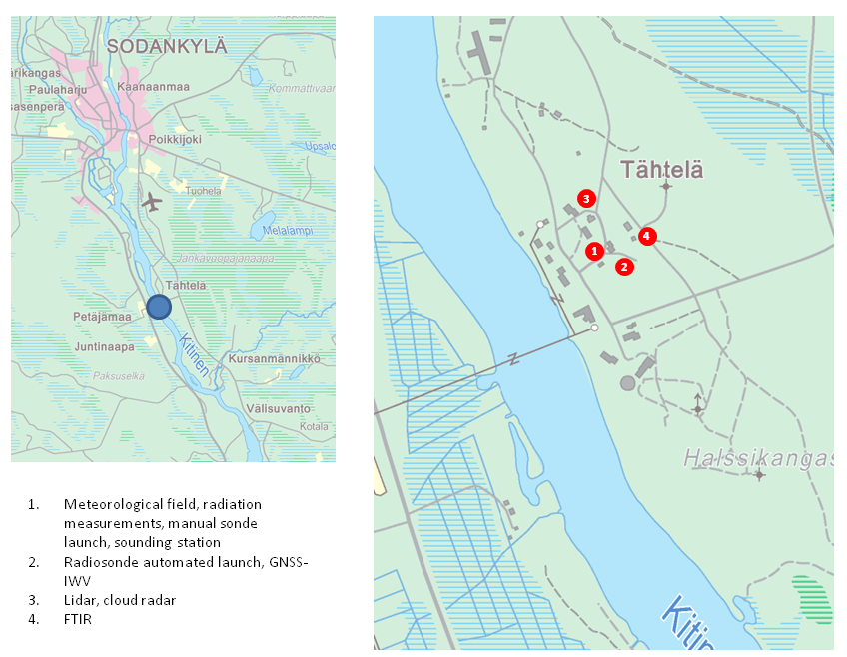

Figure 1: Location of site, scale level of the close up-map (right) is 1:8000.
FMI Sodankylä facility is located in northern Finland, about 6 km south of Sodankylä. The coordinates of the TCCON instrument are 67.3668º N, 26.6310 º E, 188 m.a.s.l. The observatory around the TCCON facility has long term history. The continuous weather observations at the present location started in year 1908. In 1949 FMI established an aerological observatory at Sodankylä. Since then balloon soundings have been performed at Sodankylä on regular basis. The site is relatively consolidated, since most of the relevant instruments are located in Tähtelä (Figure 1). Distances between the instruments are generally less than 200 m. The site participates also in some other networks, such as GRUAN and GAW. List of atmospheric measurements at the FMI Sodankylä facility and the starting year of each measurement program is presented in Table 1. Regular sonde launches at the FMI include CFH (Cryogenic Frostpoint Hygrometer), ozonesondes and RS92 radiosondes. The facility has an automated launcher for the radiosondes Vaisala RS92. The AirCore system was established in September 2013 in collaboration with the University of Groningen. Since then several improvements have been introduced to the AirCore system, including data analysis methods and recovery system.

Table 1: List of atmospheric measurements at the FMI Sodankylä facility and the starting year of each measurement program.
Derived Parameter | Start Year
TCCON Observations  CO2, CH4, CO, H2O and other gases | 2009
AirCore Observations  CO2, CH4, CO, using Picarro analyser | 2013
Other Balloon-borne Observations  Radiosondes:  temperature, air pressure, relative humidity, wind speed and wind direction  Ozonesondes:  ozone  Cryogenic Frostpoint Hygrometer:  water vapour mixing ratio profile | 1949  1989  2002
Other Total Column Observations  GNSS water vapor  Brewer #037 and #214:  ozone  Cimel sun photometer:  Aerosol optical depth | 1995  1988  2007
Surface Observations  temperature at 2m, temperature at ground, dew point temperature, dir pressure, air relative humidity, wind speed, wind direction, precipitation, cloud height, amount of clouds, Visibility, snow depth, prevailing weather | 1908
Other Profile Measurements  Cloud radar  Doppler lidar  Ceilometer | 2012  2012  2009
Solar Radiation Observations  global, diffused, reflected, direct radiation, radiation balance, PAR, sunshine duration, global and spectral UV, aerosol optical depth, albedo | 1957

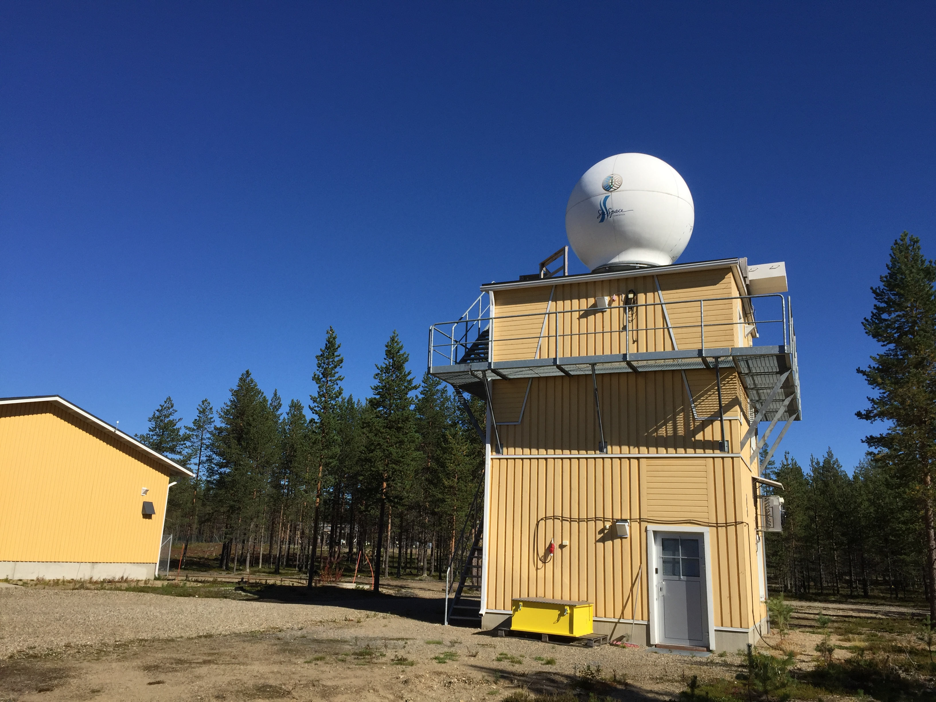

Figure 2: TCCON building at the FMI Sodankylä facility. Solar tracker Bruker A547N is installed on the roof of the building.

References

Kivi, R. and Heikkinen, P.: Fourier transform spectrometer measurements of column CO₂ at Sodankylä, Finland, Geosci. Instrum. Method. Data Syst., 5, 271-279, doi:10.5194/gi-5-271-2016, 2016. Available at http://www.geosci-instrum-method-data-syst.net/5/271/2016/

Wunch D., Toon, G. C., Blavier, J.-F. L., Washenfelder, R. A., Notholt, J., Connor, B. J., Griffith, D. W. T., Sherlock, V., and Wennberg, P. O.: The Total Carbon Column Observing Network, Phil. Trans. R. Soc. A 369, 2087–2112, doi:10.1098/rsta.2010.0240, 2011.

